Day 9 - 13th June- 113195064 - Bondili Bhavya Charitha

**TASK01:**

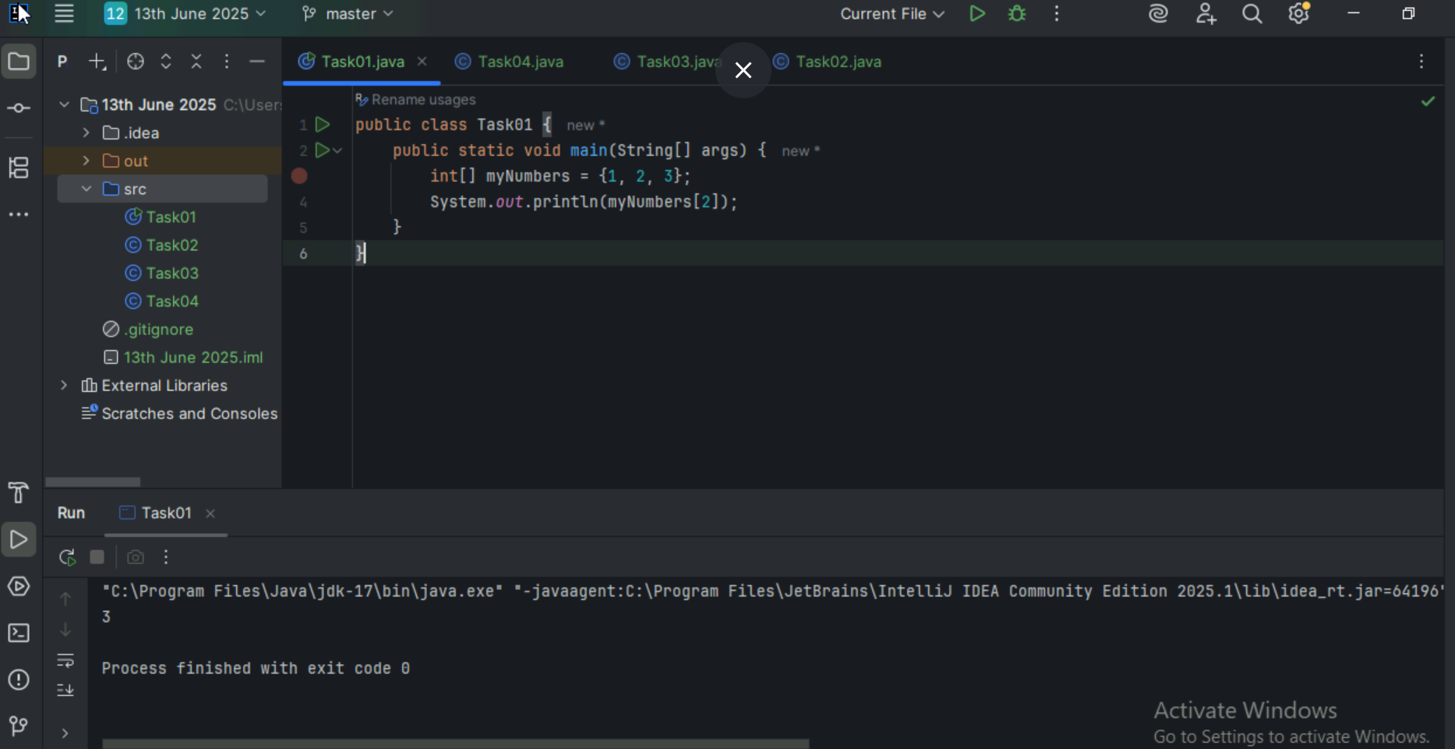

**TASK02:**

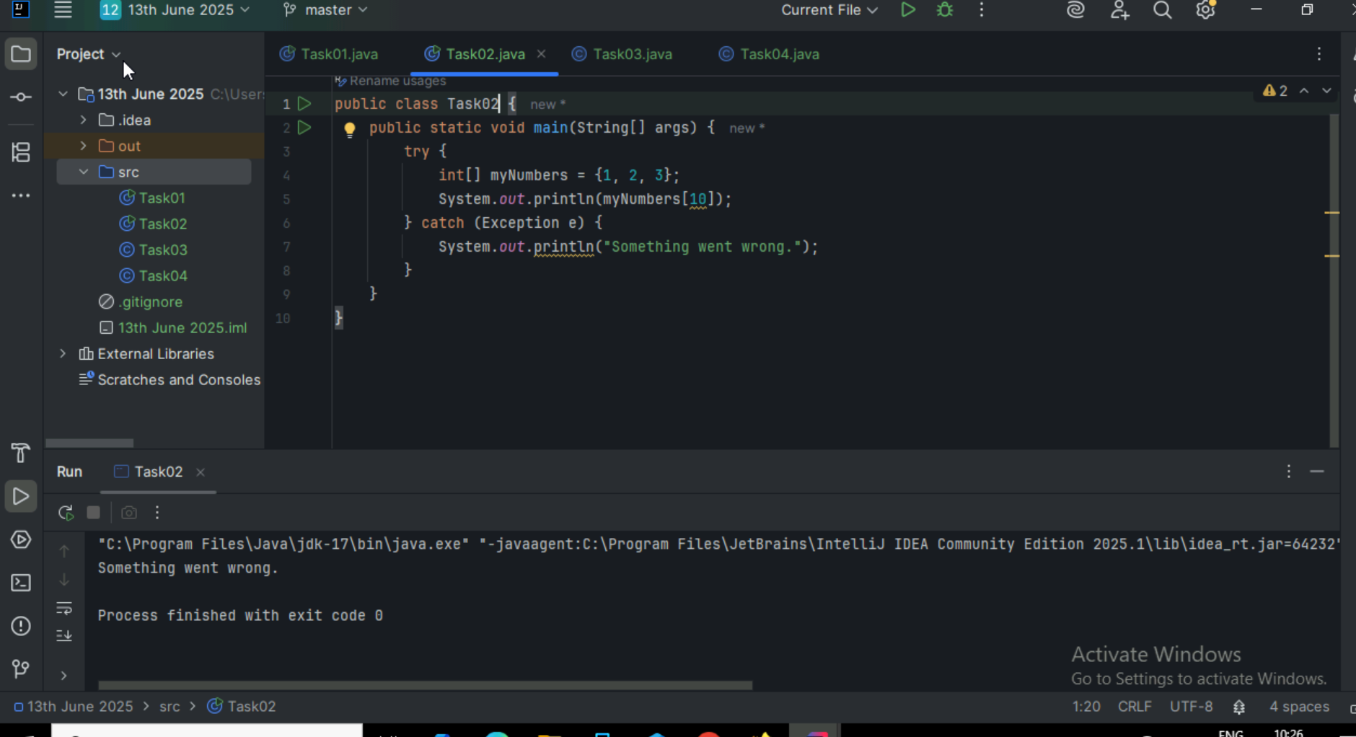

**TASK03:**

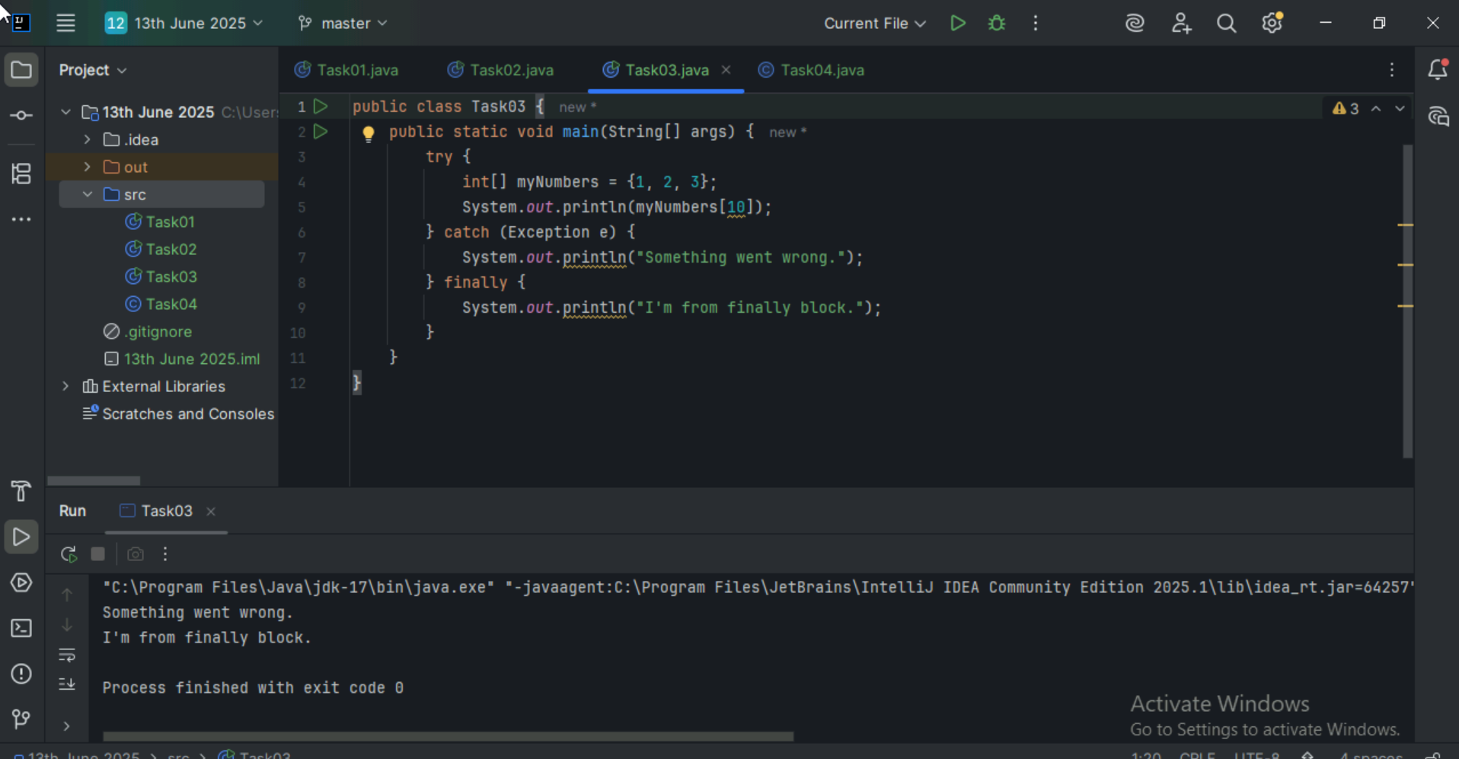

**TASK04:**

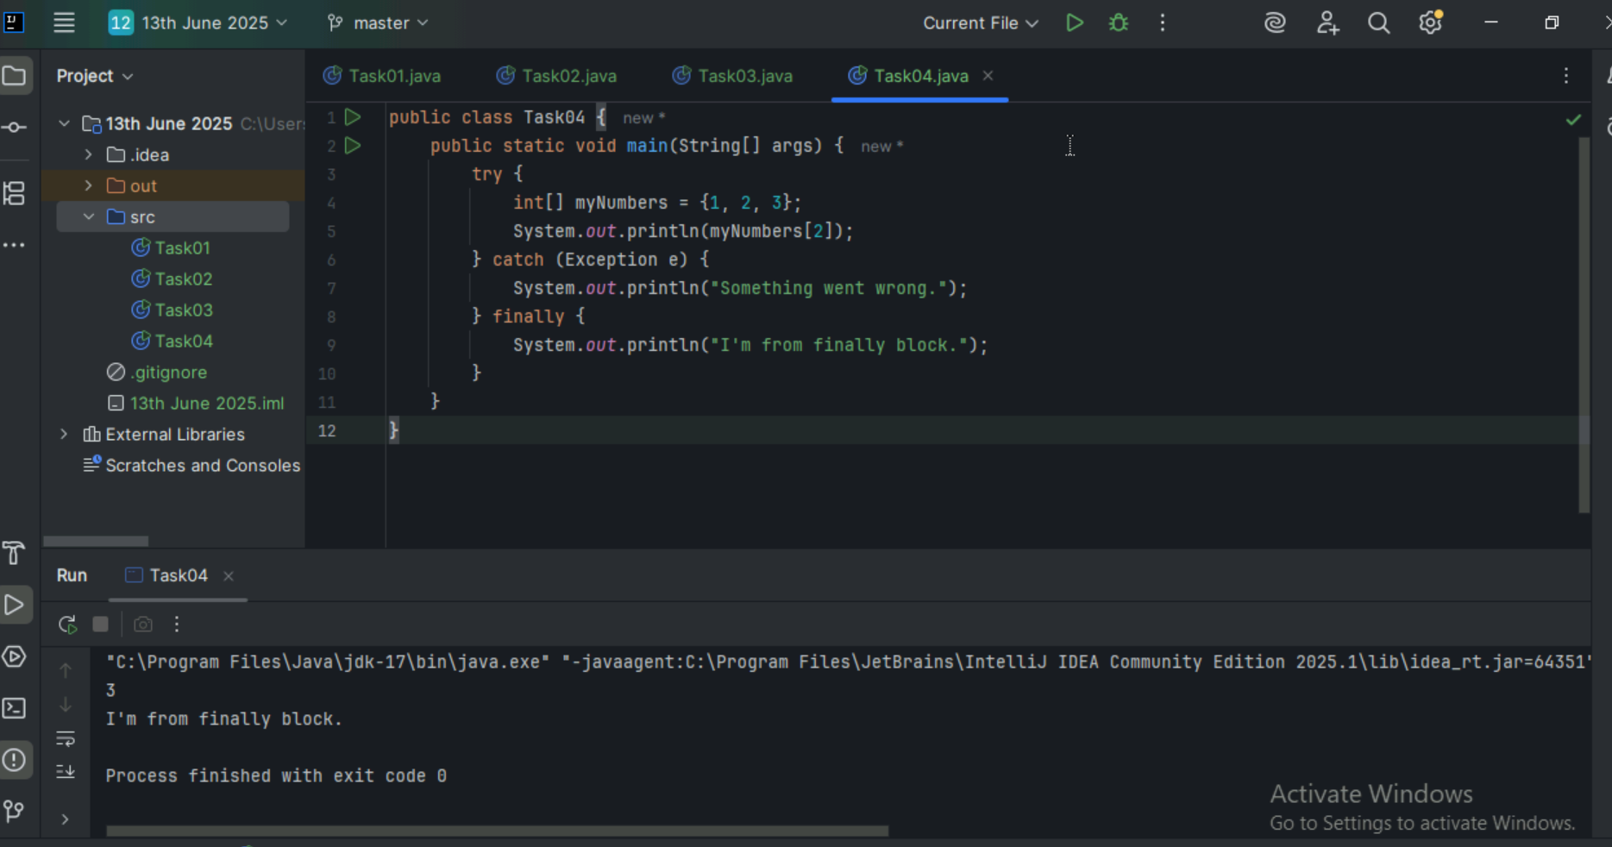

**TASK05:**

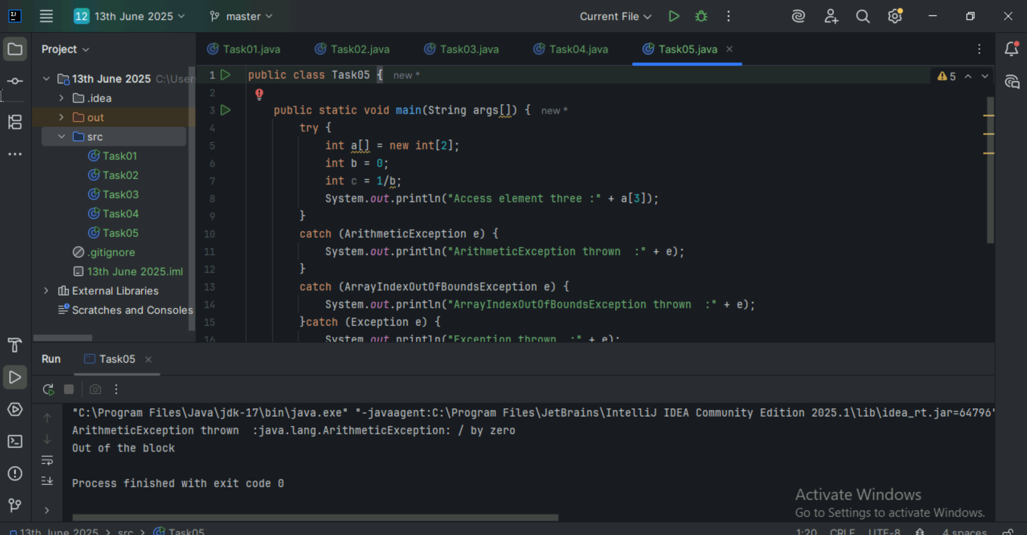

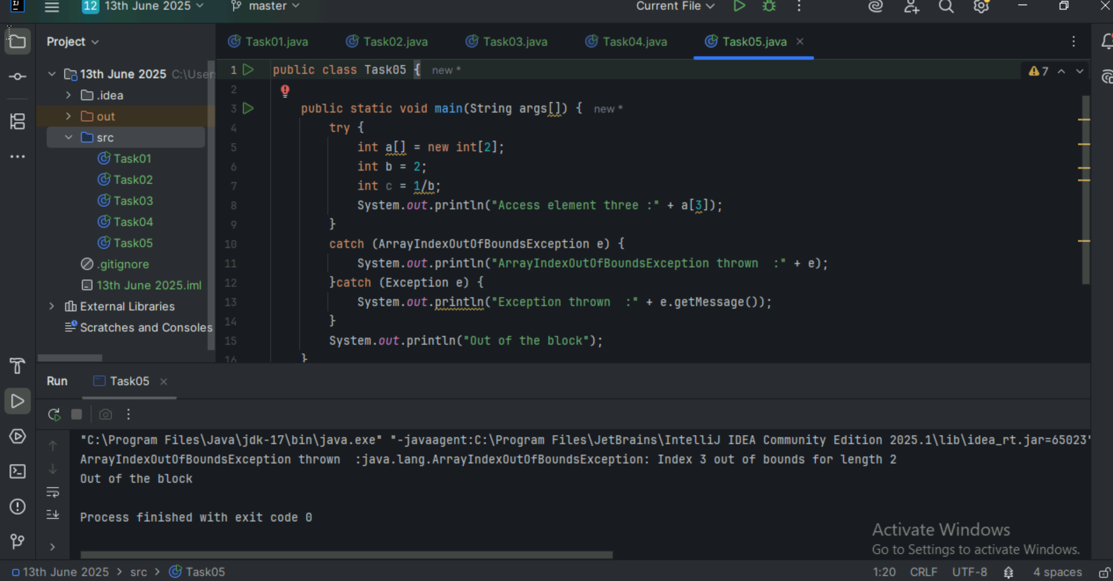

**TASK06:**

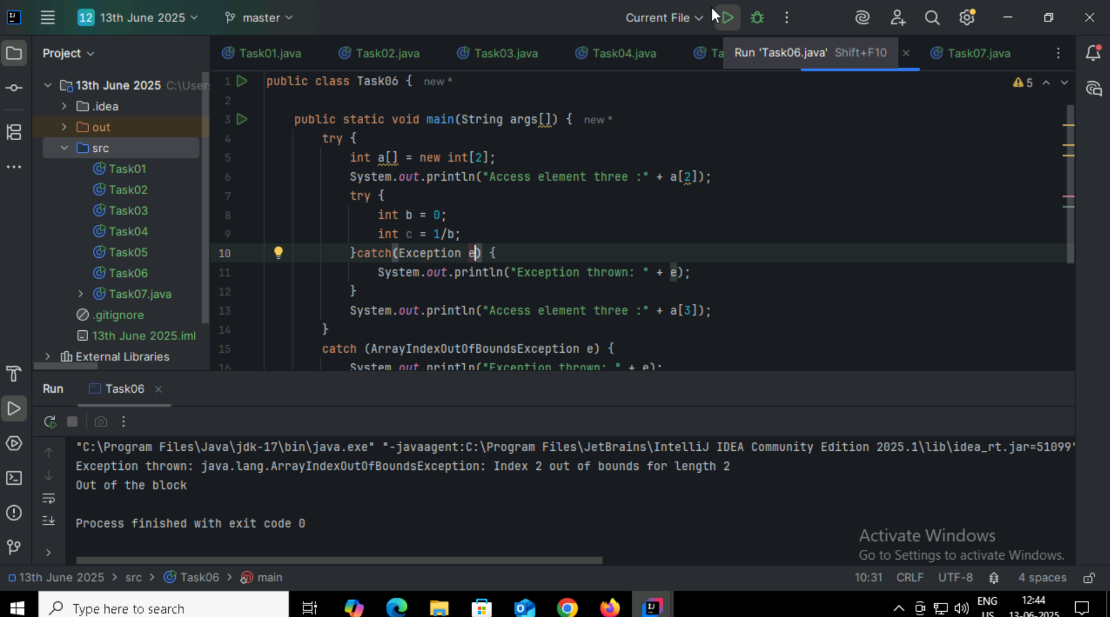

**TASK07:**

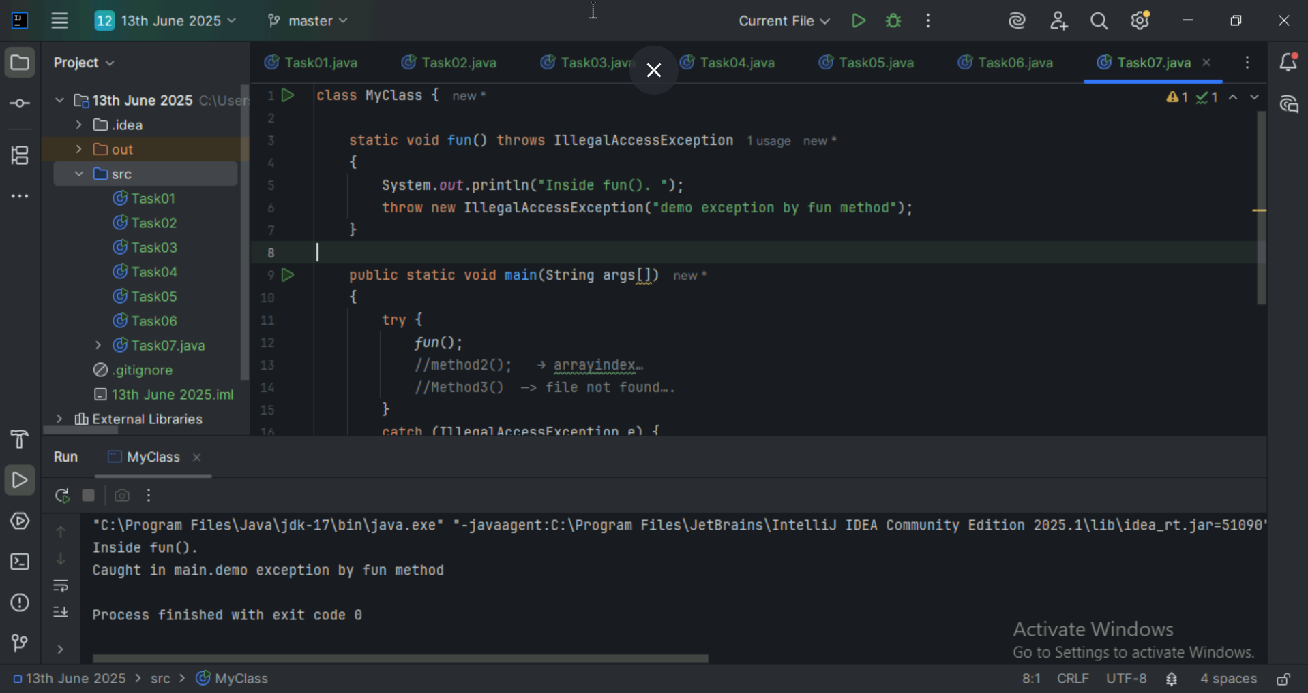

**TASK08:**

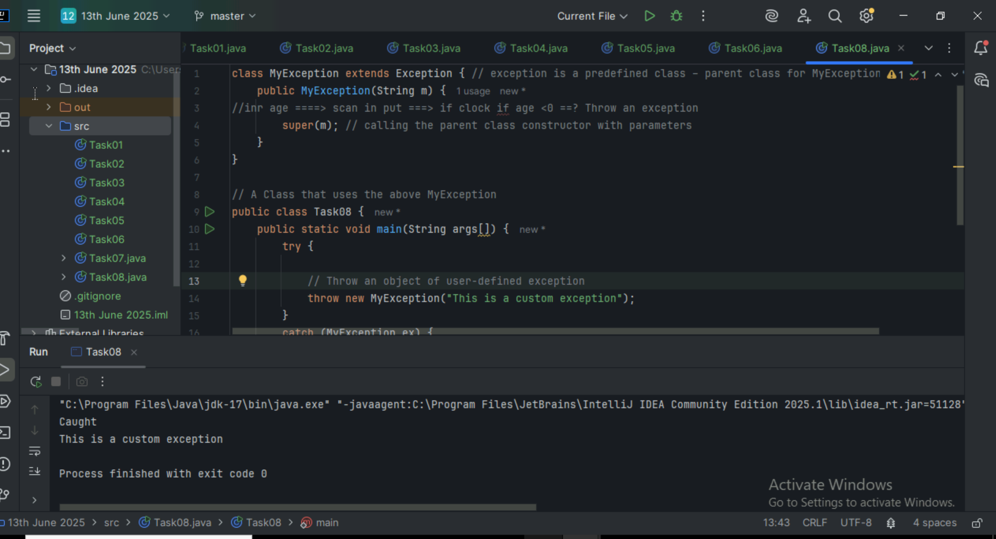

**TASK09:**

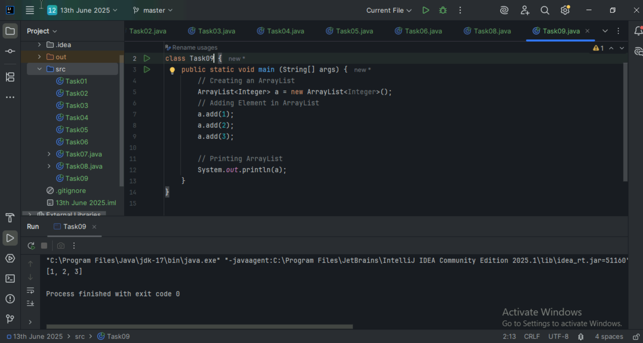

**TASK10:**

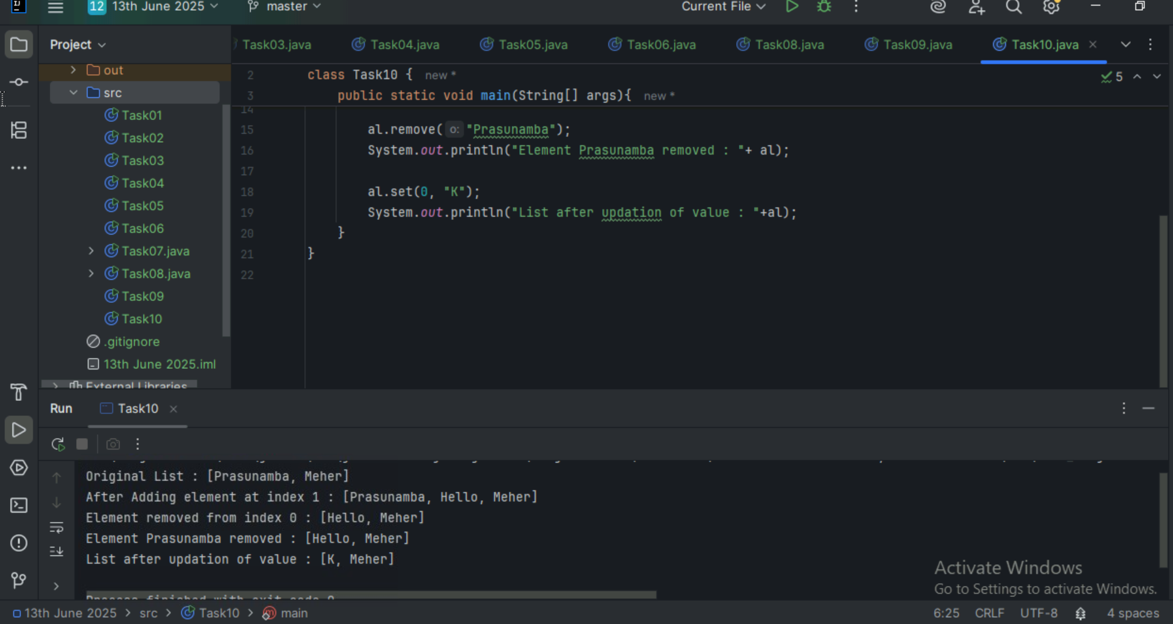

**TASK11 and 13:**

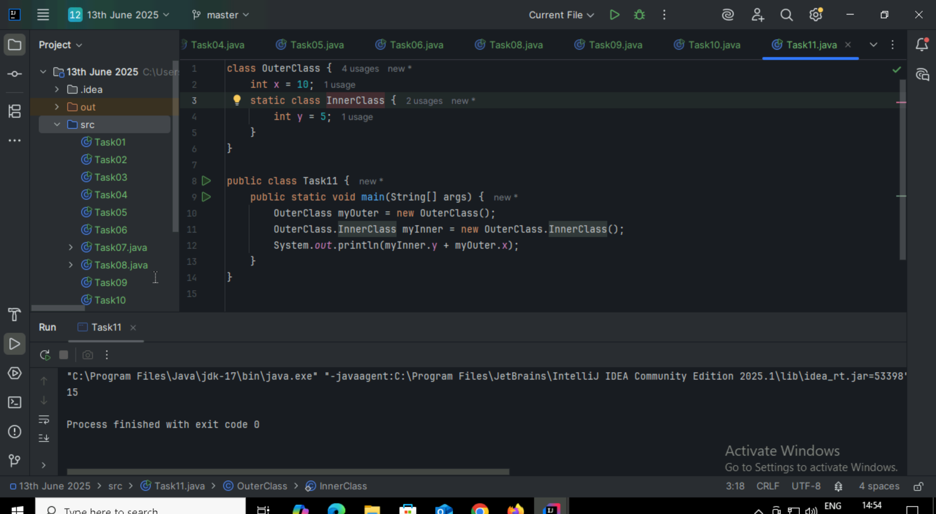

**TASK12:**

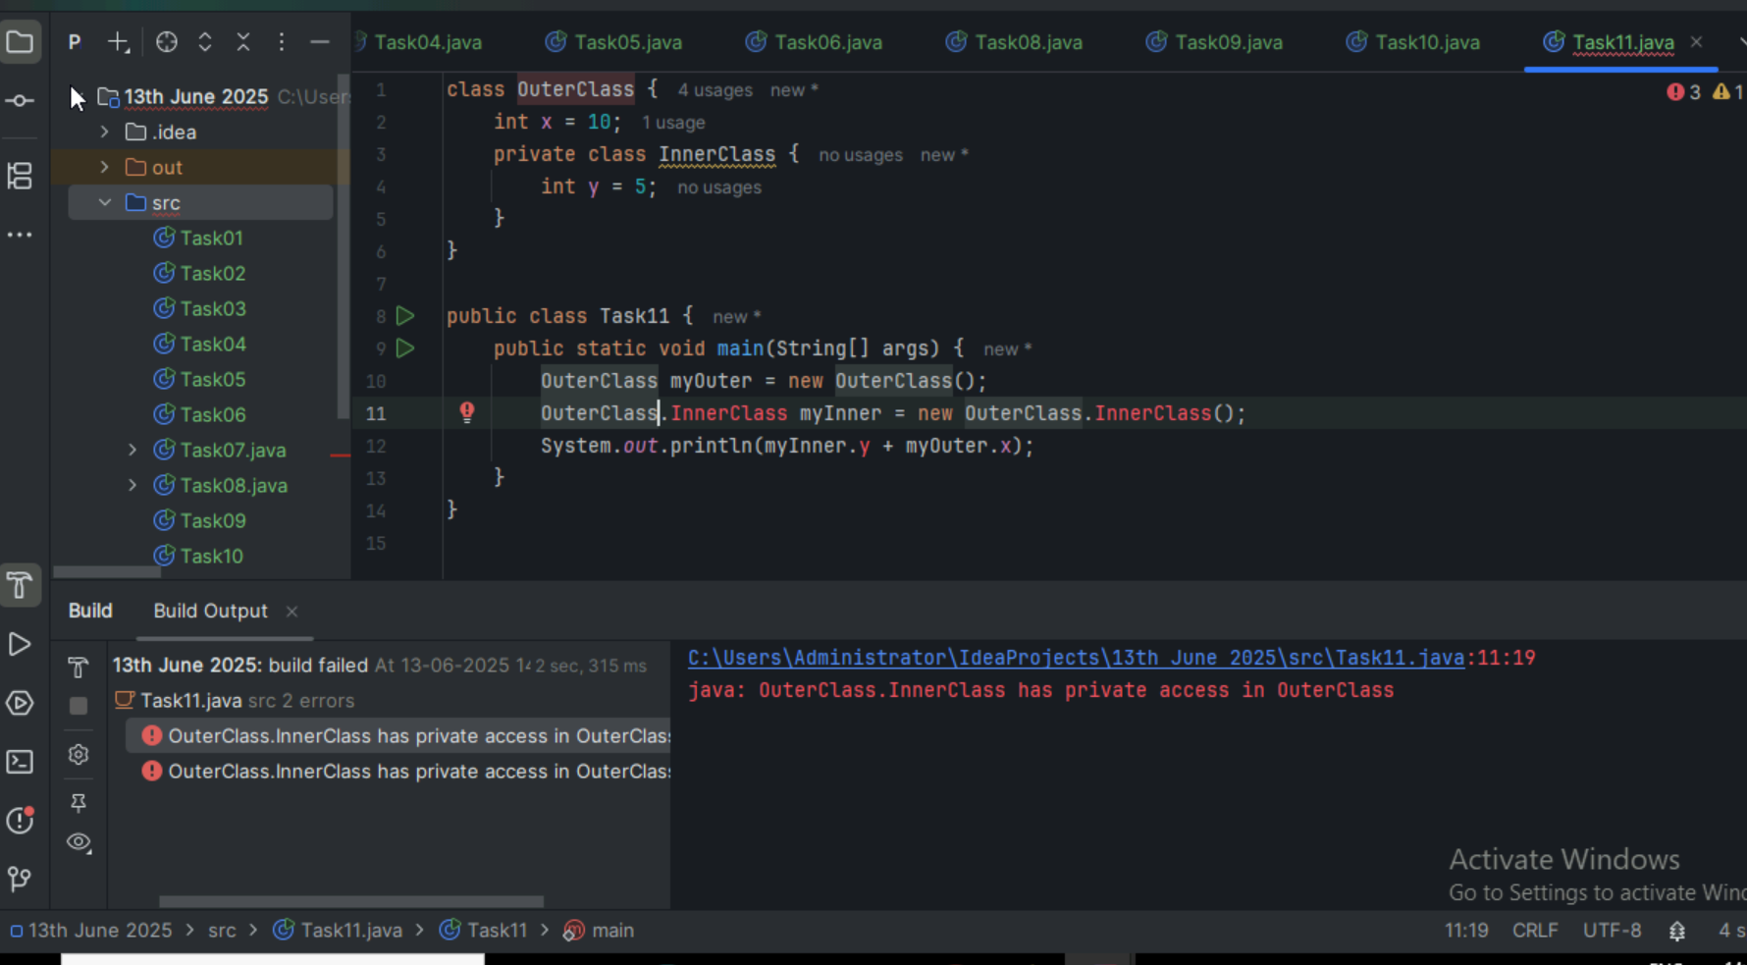

**TASK14:**

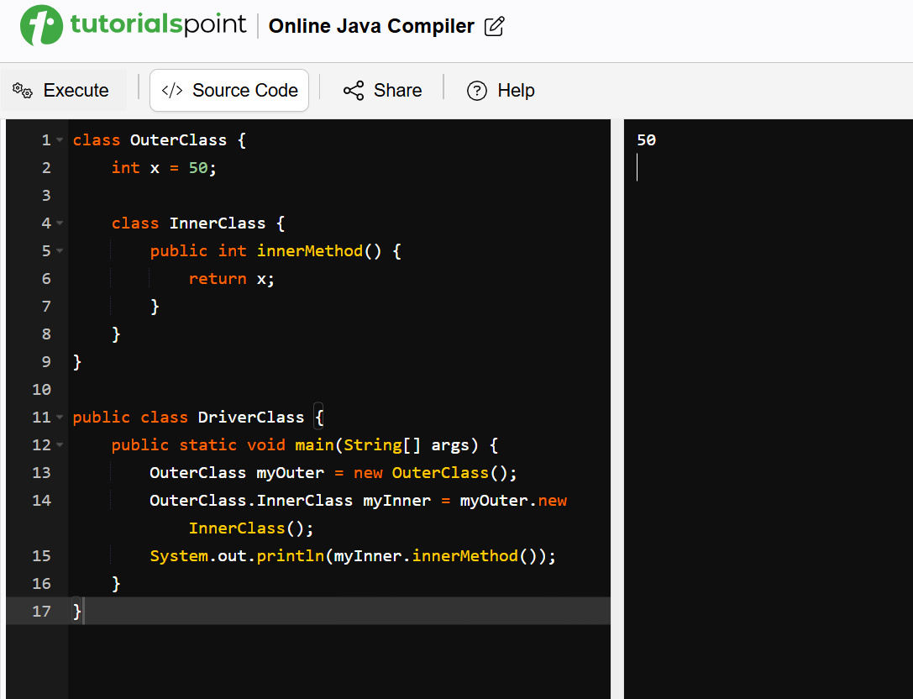

**TASK15:**

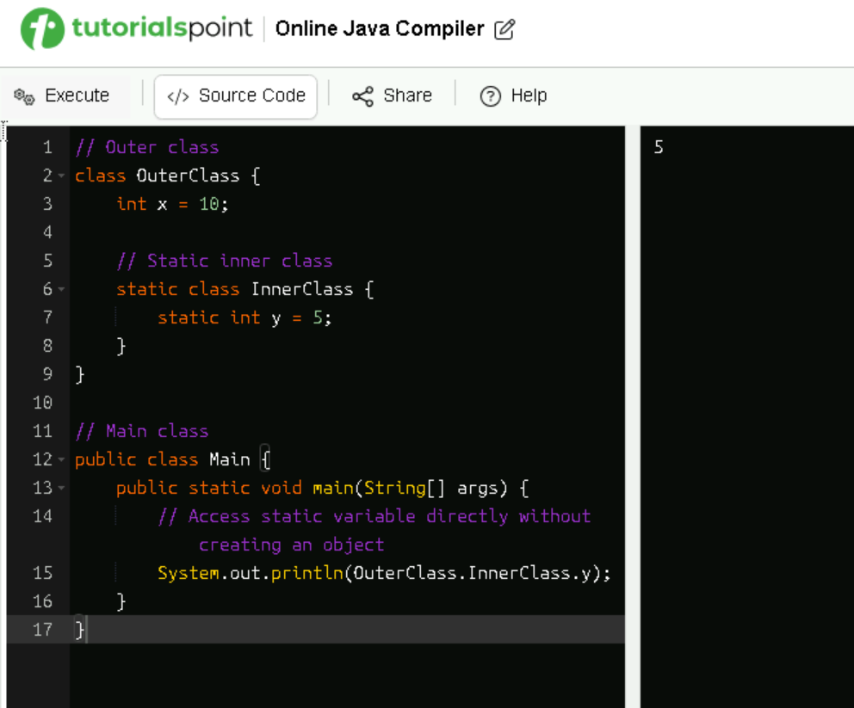

**TASK16:** OOPS Concepts – Done

**TASK17: What are the features of Java 8?**

Java 8 Features:

* Lambda Expressions
* Interfaces can have body (default and static)
* Foreach
* Collection API
* Stream API
* Java io improvements
* Functional Interfaces
* Method references
* Time API

**TASK18:**

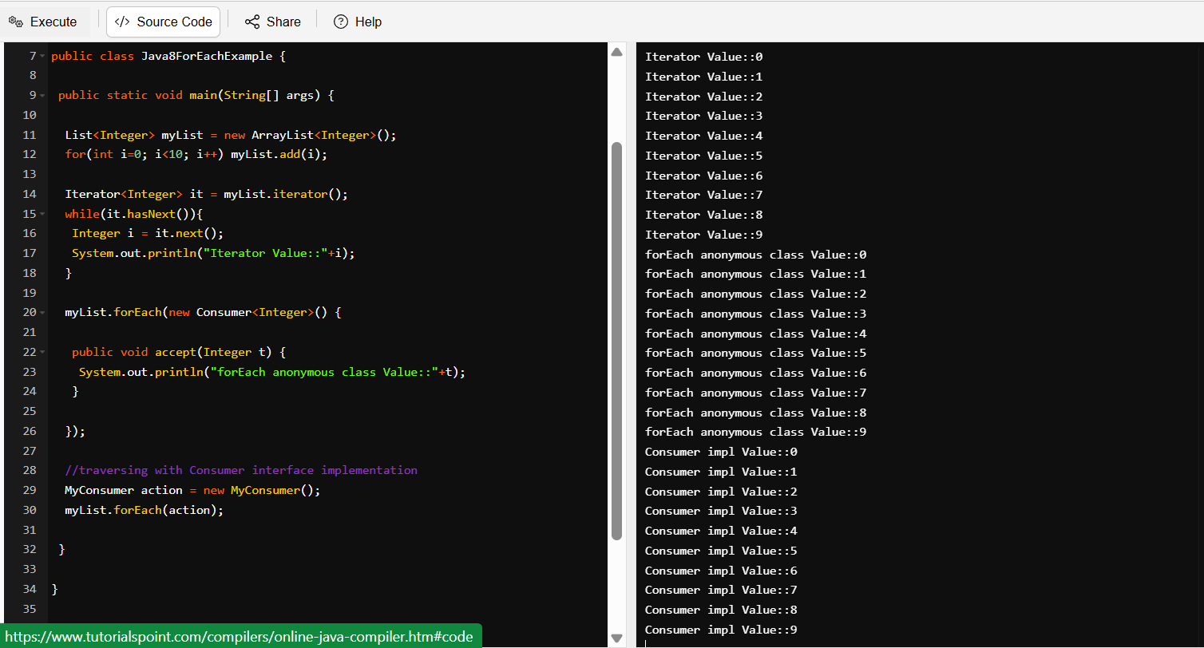

**TASK19:** Java 8 Features – Done through Link

**TASK20:**

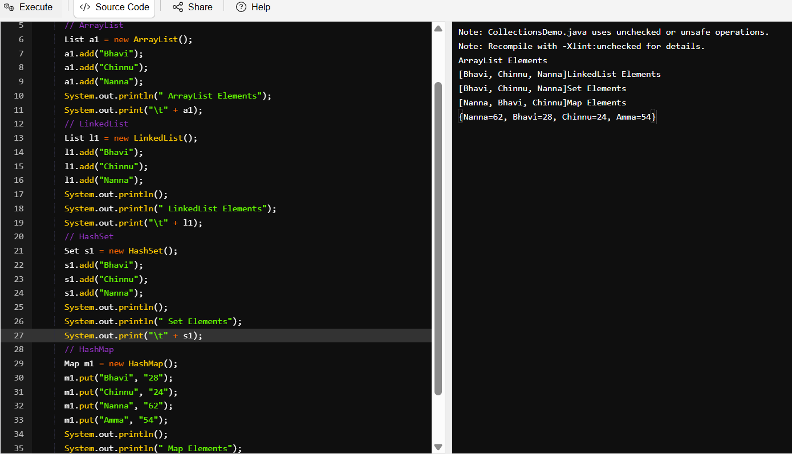

**TASK21:**

